Copernicus Climate Change Service Global Land and Marine Observations Database

Data reader. User manual

**Issued by:** NUIM / Peter Thorne

**Date:** 31/12/2018

**Ref:**C3S_D311a_Lot2.3.4.4-2018_201812_ Marine_code_v1

**Official reference number service contract:** 2017/C3S_311a_Lot2_NUIM/SC1

Contributors

natural environment research council, National oceanography centre (NERC noc)

1. David I. Berry

2. Elizabeth C. Kent

natIONAL UNIVERSITY OF IRELAND MAYNOOTH

1. Peter Thorne

2. Corinne Voces

National oceanic and atmospheric administration’s national centers for environmental information

1. Eric Freeman

# Table of Contents

1. Table of Contents 3

2. Introduction 6

3. Tool overview 7

4. Tool set up 8

4.1 Initial tests 9

5. Use syntax. Input and output 11

6. Data models and the extraction, transformation and validation flow 13

7. Data models 16

7.1 Building an external data model 16

8. Data model schema files 18

8.1 Schema file templates 19

8.2 Schema header block 19

8.3 Schema elements block 21

8.4 Schema sections block 26

8.4.1 Section header 27

8.4.2 Section elements 28

9. Data model code tables 29

9.1 Code table templates 29

9.2 Common features 30

9.3 Simple code tables 30

9.4 Nested code tables 30

9.5 Range-keyed code tables 31

9.6 Assigning date(datetime) elements to keys 32

10. Annex 33

10.1 Reading supplemental data 33

10.2 Time stamps management 33

10.3 File format models 33

10.3.1 Fixed width simple models 33

10.3.1.1 No sections 33

10.3.1.2 Elements in sections 33

10.3.2 Fixed width complex models 34

10.3.2.1 IMMA1 model – multiple and optional sections 34

10.3.2.2 TDF-11 model – multiple and exclusive sections 34

10.3.2.3 TD14 model – multiple reports per record with common sections ( or header) 34

10.3.2.4 TD14 model – multiple reports per record 35

10.3.3 Field delimited simple models 35

10.3.3.1 No sections 35

10.3.3.2 Elements in sections 35

10.3.4 Field delimited complex models 35

Executive Summary

The C3S 311a Lot 2 (Global Land and Marine Observations Database) service is concerned with the provision of globally available land and marine surface meteorological records. The service includes inventorying of, and brokering access to, data sources, their harmonization (via conversion to a Common Data Model (CDM), merging, and quality assurance) and their provision via the Copernicus Climate Change Service (C3S) Climate Data Store (CDS).

The version history is given below:

|  |  |  |
| --- | --- | --- |
| **Version** | **Release Date** | **Release notes** |
| 1.0 |  |  |
| 2.0 |  |  |

# Introduction

The Copernicus Climate Change Service (C3S) Global Land and Marine Observations Database service provides brokered access to global historical holdings of surface meteorological observations. It builds upon existing national, regional and global efforts to create an augmented set of quality assured holdings that can be used to create datasets, products and services.

**This document will contain relevant detailed information on the software and configuration used to produce the marine data holdings for service providers to be able to access, use, modify and/or update where necessary. The current version of this document is focused on the data flow leading to the December 2018 beta release (header and observations tables) and the scripts and software tools derived from it.**

The document is ordered as follows:

* Section 2 summarizes the marine code requirements.
* Section 3 describes the marine main data flows.
* The Annex to this document provides further insight into scripts and tools.

# Tool overview

The mdf_reader is a python3 tool designed to read *meteorological data formats* where:

* Data are stored in a human-readable manner: “ASCII” format
* Data are organized in single line reports
* Reports have a coherent internal structure that can be modelized
* Reports may be fixed width or field delimited

The mdf_reader uses the information provided in a *data model[1]* to read data to a *python* *pandas* *DataFrame* object (DF) with column names and data types set according to each of the element’s description in the data model. In addition to reading, the mdf_reader validates the data against the data model provided.

This tool outputs a python dictionary with the following object:

1. A *pandas* DF with the data values
2. A boolean *pandas* DF with the data validation mask
3. A dictionary with a simplified version of the input data model.

The reader allows for basic transformations from the data values reported in the original data source to the final value stored in the output DF. This feature includes basic numeric data decoding (base36, signed_overpunch) and numeric data conversion (scale and offset).

Mention to supplemental data

Several data models have been added to the tool, meaning that these are internally available to it. Data from other data models than those already available can be read: providing it meets the basic specifications listed above, a model can be built externally and fed into the tool.

This manual is organized as follows:

* Guidelines to tool access and set up in section 4.
* Use syntax, input arguments and output are described in section 5.
* The lifecycle of a data element and its attributes within the tool is explained in section 6.
* The tool’s data model concept and building guidelines are detailed in sections 7, 8 and 9.

# Tool set up

The mdf_reader is currently maintained in GitLab. It needs to be downloaded to a directory of choice from GitLab. An __init__.py file must exist in the directory where the tool is placed: this file makes Python treat this directory as containing packages:

> (mkdir myDir)

> cd myDir

> git clone https://gitlab.noc.soton.ac.uk/iregon/mdf_reader.git

> touch __init__.py

Before importing the tool in a python session, the installation directory must be added to python’s path. This can be done either before initiating a python session:

> toolParentDirectory = ‘/../myDir’

> export PYTHONPATH=$*toolParentDirectory*:${PYTHONPATH}

> python

> python> import mdf_reader

Or already in the python session:

> python

> python> toolParentDirectory = ‘/../myDir’

> python> import sys

> python> sys.path.append(toolParentDirectory)

> python> import mdf_reader

Check for dependencies after anaconda update (like dtype.name)

## Initial tests

Need to adapt this section to new output objects

Some data reading cases are including to test the tool upon set up. These help getting hands on with the tool and its output.

The following lines show how to read the imma1 test data included in the tool (subset of imma1 core data and corresponding supplemental data), and how to access the full resulting DF, a section or an individual element within it, as well as how to plot them.

> python

> toolParentDirectory = ‘/../myDir’

> import sys

> sys.path.append(toolParentDirectory)

> import mdf_reader

> import matplotlib.pyplot as plt

> imma_buoys = mdf_reader.tests.imma1_buoys_supp()

# 1. Print full data values DF

> python> print(imma_buoys[‘data’])

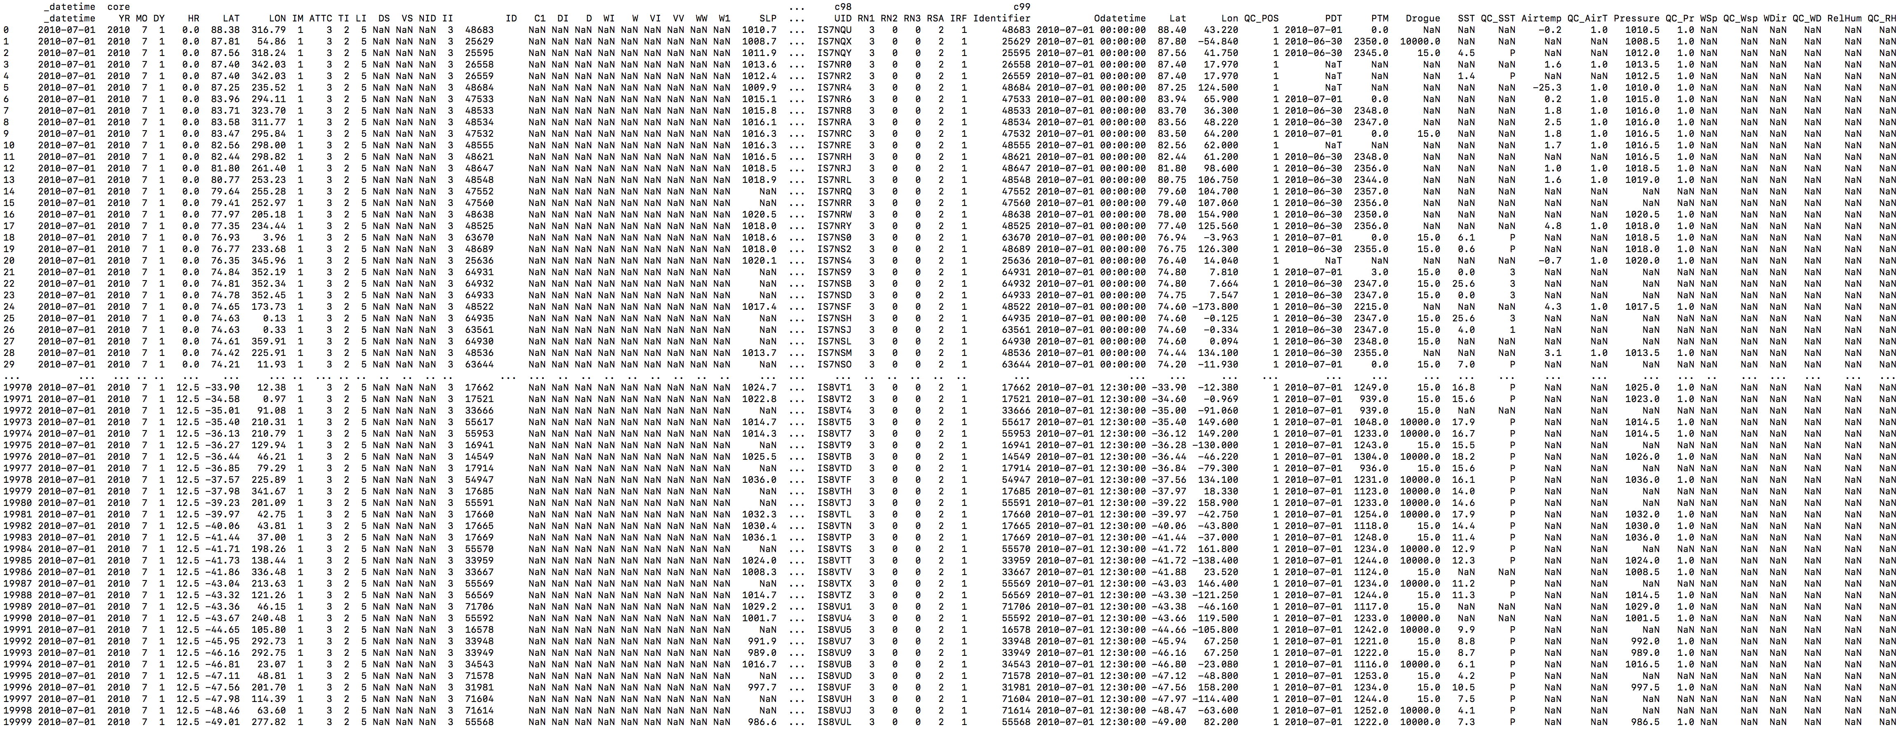

# 2. Print *c99* section

> print(imma_buoys[‘data’][‘c99’])

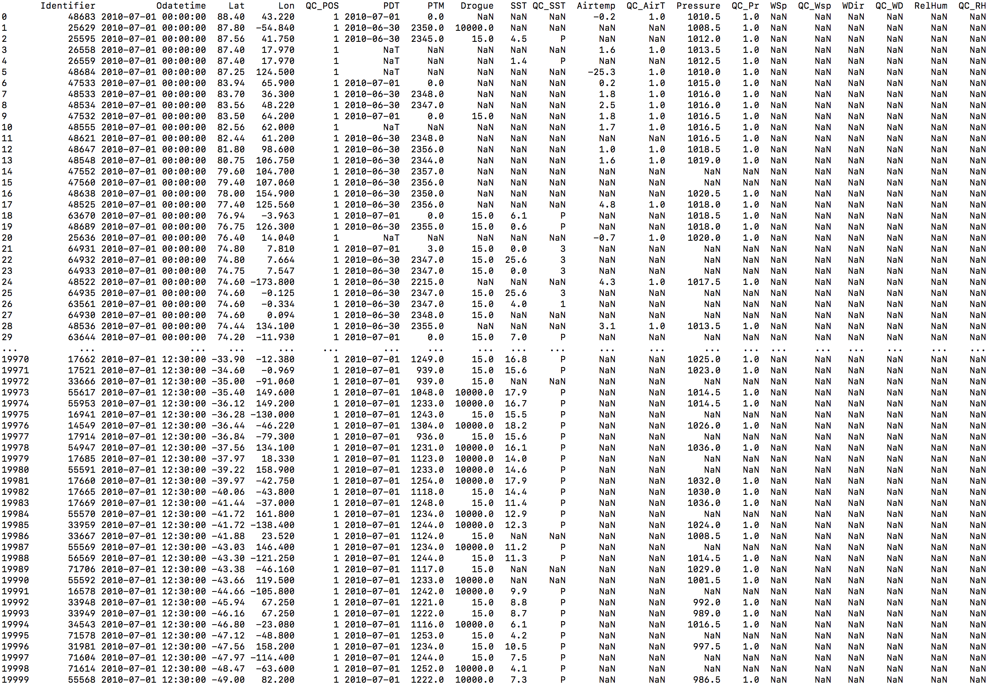

# 3. Print *PDT* variable from *c99* section

> print(imma_buoys[‘data’][‘c99’][‘PDT’])

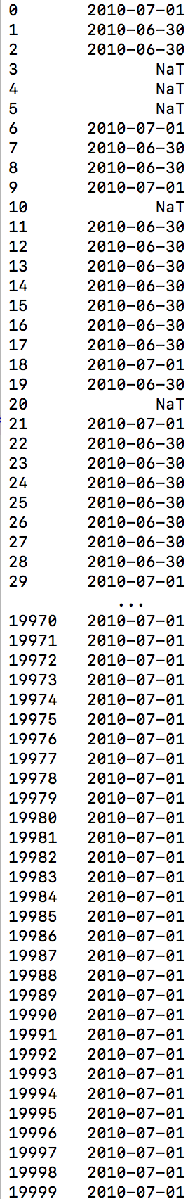

# 5. Plot *SST* and *AT* variables from *core* and *c99* sections

> ax = imma_buoys[‘data’] [‘core’][‘AT’].plot(label = 'Core AT')

> imma_buoys[‘data’] [‘c99’][‘Airtemp’].plot(ax = ax,label = 'c99 Airtemp')

> imma_buoys[‘data’] [‘core’][‘SST’].plot(ax = ax,label = 'Core SST')

> imma_buoys[‘data’] [‘c99’][‘SST’].plot(ax = ax,label = 'c99 SST')

> plt.legend()

> plt.show()

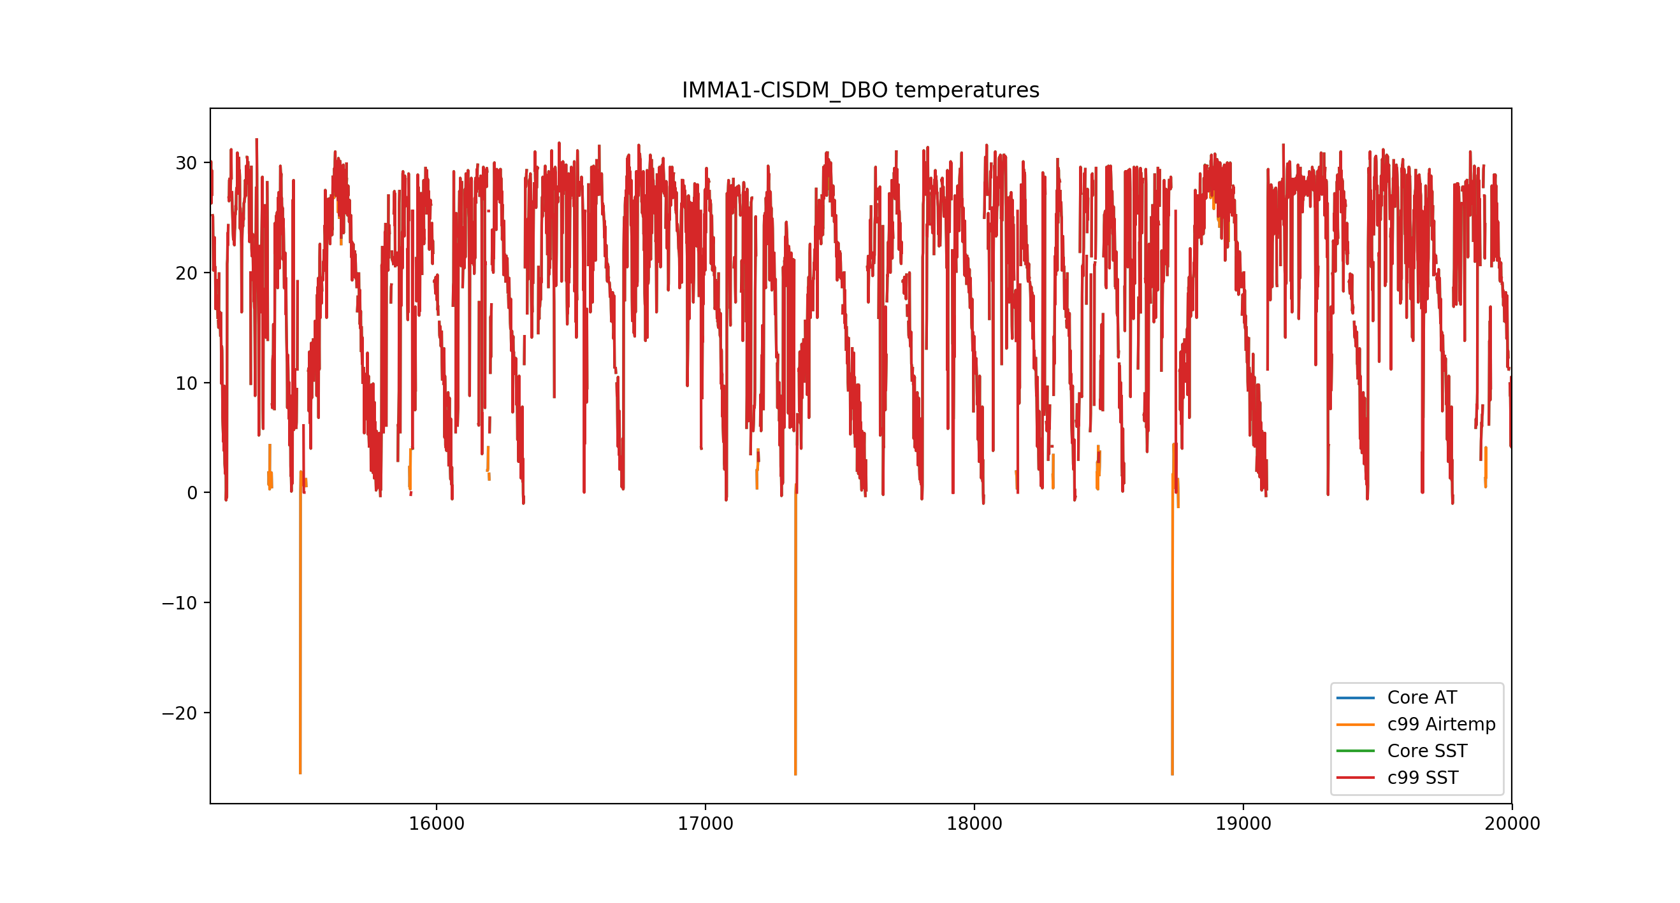

# Use syntax. Input and output

The mdf_readerreads input data to a *python* *pandas* *DataFrame* object and validates it against its declared data model.

The output of this module is a *python* dictionary with three objects:

* ***‘data’***: *python* *pandas* *DataFrame* with data values.
* ***‘atts’***: *python dictionary* with attributes of each of the output elements inherited from the input data model schema.
* ***‘valid’***: boolean DF with the results of the validation of each of the data model elements in its columns.

The calling sequence from a python session is:

mdf_reader.***read***(source, data_model = None, data_model_path = None,

sections = None, chunksize = None, skiprows = None, out_path = None,

supp_section = None, supp_model = None, supp_model_path = None )

The calling sequence from the shell terminal is:

python *mdf_reader_dir*/***read.py*** source data_model = None data_model_path = None

sections = None chunksize = None skiprows = None out_path = None

supp_section = None supp_model = None supp_model_path = None

List of arguments:

***source:*** input data to read. Valid data sources are: data file path, *pandas* DataFrame or io.parsers.TextFileReader objects or in-memory text streams (io.StringIO object). Type: string.

List of keyword arguments:

***data_model:*** data model name (for internally available data models). See section 7 for info on how to access available data models reference names. Type: string.

***data_model_path:*** path to external data model directory. See section 7.1 for reference on building data models. Type: string.

Either *data_model* or *data_model_path* must be provided.

***sections:*** optional. Applies to data models with multiple sections. List of strings with section names to output. Default is all defined in the data model. Type: list of strings.

***chunksize:*** optional. Integer with chunksize (number of lines). Will return a pandas.io.parsers.TextFileReader object for iteration instead of a plain DataFrame (see http://pandas.pydata.org/pandas-docs/stable/user_guide/io.html#io-chunking). Default is no chunking.

Applies to data file and in-memory text streams *source* types. If *source* is already an iterator (io.parser.TextFileReader type) then the output is also an iterator that inherits the chunksize from the source and this argument is ignored if provided.

Type: integer.

***skiprows:*** optional. Number of lines to skip at the start of the file. Default is 0. Type: integer.

***outpath:*** optional. Path to directory to output the reader results. Data values and valid mask DataFrames will be saved as comma separated value files: ***outpath***/data.csv and ***outpath***/valid_mask.csv. The attributes dictionary will be saved as a json file: ***outpath***/atts.json. Type: string.

***supp_section:*** optional. Supplemental section name. If given, the supplemental section is read using the data model given in either *supp_model* or *supp_model_path*. Default is None: the corresponding section (if existing in the data model) is a single column in the output DataFrame, with the full supplemental section as a string.

Currently, only simple data models (with no sectioning) are supported for supplemental sections.

Type: string.

***supp_model:*** supplemental section data model name (for internally available data models). Type: string.

***supp_model_path:*** path to external supplemental section data model directory. Type: string.

Either *supp_model* or *supp_model_path* must be provided if *supp_section* is provided.

# Data models and the extraction, transformation and validation flow

The individual data elements’ definition in the data model determines how these are extracted, transformed and validated within the tool.

If the data model has its data elements organized in sections, the reader first identifies the reports’ string chunks corresponding to the different sections. If the data model has no sections, the reader works with the full report as an only chunk. Afterwards, data elements are extracted from each of these chunks, as schematized in Figure 8, where the different steps in the lifecycle of the data elements in the reader are linked to the attributes (orange text in the figure) they have been assigned in the data model.



Figure 8. Schematic representation of the integral process of reading, transformation and validation of a data element.

**Data element extraction and transformation** from the initial string to the output data frame occurs mainly in 3 steps:

1. **Elements extraction and missing data tagging with *pandas.read_fwf*|*csv:*** individual data elements are extracted as ‘objects’ from the full report string and missing data recognized as NA/NaN values in the resulting data frame.

Strings recognized as missing from the source are *pandas* defaults, plus:

* those defined in data model’s *missing_value* attribute.
* blanks if *disable_white_strip* is not True

1. **Unpacking of encoded elements:** data elements with *encoding* defined in its attributes are decoded and casted to their declared *column_type**[2]*. Elements where decoding fails are marked as NA/NaN values in the resulting data frame.
2. **Element conversion:** data elements are converted (and optionally transformed) to their final data types (and units).

*Numeric* type elements:

* 1. Safe conversion to numeric: NaN where conversion is not possible.
  2. Optionally, application of *scale* and *offset: offset + scale*\*i
  3. Safe conversion of *column_type2*

*object*, *string* and *key* type elements: leading and trailing whitespace stripping unless otherwise declared in *disable_white_strip* (disable all, leading or trailing blank stripping)

*datetime* type elements: safe parsing to datetime with *pandas.to_datetime*(), with NaT where conversion is not possible

**Data model validation** is initiated after element unpacking and conversion: new Na/NaN values in the data (not identified as missing values during extraction) are understood to fail unpacking or conversion, and thus, to not validate the data model. The resulting preliminar validation mask values are:

* **False**: invalid decoding, conversion
* **True:** missing data, rest

Once elements are in the final form, *numeric* and *key* elements are validated against their corresponding attributes in the data model (*valid_max*|*valid_min* and *codetable*, respectively), with the final values in the validation mask being:

* **False**: invalid decoding, conversion, data model values
* **True:** missing data, rest

Overall, the validation process exception handling is:

* Missing values: True
* Numeric type elements where either upper|lower bound is missing: False
* *key* type elements where no codetable is found (or defined in the data model): False
* Rest: True

# Data models

In the tool’s context, a *data model* is the combination of a schema file with information on the file format and its contents and, optionally, a set of code tables with the *key*:*value* pairs the model uses to encode information contained in some data elements.

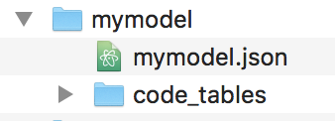

Figure 1. mdf_reader data model concept

The mdf_reader supports reading and validation of both internal/registered and external data models:

* An **internal data model** has its model registered within the tool. To read and validate data from these models, we only need to pass its reference name to the reader and validation modules, using the argument *data_model* (*supp_model* for supplemental data). A list of the reference names for internally supported data models can be accessed through the tool’s properties:

> python> mdf_reader.properties.supported_file_formats

* An **external data model** is a data format that is unknown to the tool. If the data model meets the specifications for which the tool was built, then a model can be built externally and fed into it for both data reading and model validation using the argument *data_model_path* (*supp_model_path* for supplemental data)

The following sections explain how to build a valid data model for the mdf_reader and give detailed information on its components: the schema file and the code tables.

## Building an external data model

The main steps to create a data model for the mdf_reader are:

1. Create a valid **directory** tree to hold the model (*mymodel*) like in Figure 1. The directory path is the *data_model_path* (*supp_model_path*) argument to the reader.
2. Create a valid **schema** file /***mymodel***/***mymodel***.json. Section 8 details the schema file contents and format.

To create the schema file, some basic aspects of the data model need to be clear beforehand:

* + Is the data delimited or fixed width?
  + Are the reports organized in one or multiple sections?

With this in mind, one can access schema file templates available from within the tool as explained in section 8.1.

1. Create valid **code tables** /*mymodel*/code_tables/*table_name*[i].json if the data model includes code tables. Code tables format is explained in section 9, with section 9.1 detailing how to access code table templates.

# Data model schema files

The *schema* file gathers a collection of descriptors that enable the mdf_reader access to the content of a data model and extraction of the data it contains to meaningful units of information.

Valid *schemas* are json files that the tool accesses and stores internally as dictionaries. The basename of the schema file must be the same as the data model directory and its extension *json* (see Figure 2)



Figure 2 Schema file in the *data model*

There are two levels of information in the *schema*:

1. **General** information on the **data format layout** that helps the tool decide which approach to follow to access the data content. This information is included in the *header* block of the *schema* (see section 8.2)
2. **Specific** information on the **data elements** and, optionally, on the sections if the data model has its report elements organized in one or multiple sections. This information is included in the *elements* block of the *schema* (see 8.3), which is embedded in the *sections* block in the latter case (see 8.4).



Figure 3. Layout of a schema files for a data model with N sections (left) and a data model with no sections (right)

The following sections show how to access schema templates to create new schema files and explain the different attributes included the schema.

## Schema file templates

To ease the generation of new valid schema files, the mdf_reader has a set of schema templates, that covers the basic data file formats:

* Fixed width or delimited: fixed_width_* or delimited_*
* With no sections or with sections: *_basic* or *_sections*
* More complex options include blocks of sections which are exclusive (td11 like) or blocks of sections that are optional (IMMA1 like): *_complex_exc.json or *_complex_opt.json

To access the complete list of templates available:

> python> template_names = mdf_reader.schemas.templates()

To copy a template to edit:

> python> mdf_reader.schemas.copy_template(*template_name*,***out_path****=file_path*)

or:

> python>

mdf_reader.schemas.copy_template(*template_name*,***out_dir****=dir_path*)

### 

## Schema header block

The *header* block is the first block of the schema file, and is common to all data model types. Some of its descriptors are, however, specific to certain model types.

|  |  |
| --- | --- |
| *Scope* | *Descriptor name* |
| Common | ***delimiter****,* ***encoding****,* ***format*** |
| DATETIME PARSING | ***date_parser*** |
| *COMPLEX FORMATS* | ***multiple_reports_per_line****,* ***parsing_order****,* ***reports_per_line*** |

***format:*** file meta format type

options: mdf_reader.properties.supported_meta_file_formats. (‘fixed_width’, ‘delimited’)

applies to: all

is mandatory: true

type: string

**back to schema header index**

***delimiter:*** delimiter

options: None

applies to: ***format***.*delimited*

is mandatory: true

type: string

comments: use in ***format.***fixed_width format is possible to deal with mixed formats like the cisdm_dbo. Defaults to ‘,’ in delimited formats.

**back to schema header index**

***encoding:*** file encoding

options: python supported (include command for aliases)

applies to: all

is mandatory: false

defaults to: utf-8

type: string

comments: not currently implemented. Have to implement and test: windows encodings!

Would probably have to restrict to tested encodings, not all listed in python.encodings!

**back to schema header index**

***date_parser:*** use to build a ‘_datetime’ column from date (datetime) separate elements in the data model.

If data model has no sections: “date_parser”:{"elements":["YR","MO","DY"],"format":["%Y","%m","%d"]}

If data model has sections: “date_parser”:{"section":"core","elements":["YR","MO","DY"],"format":["%Y","%m","%d"]}

applies to: all

is mandatory: false

type: dictionary

comments: format compliant with….

**back to schema header index**

***parsing_order:*** Order in which the tool must look for sections in a report, grouped by section block types. Section block types are:

‘s’: *sequential*. Sections in this block appear as listed in all the reports.

‘e’: *exclusive*. Among the sections listed in the block, only one of them appears in every report.

‘o’: optional. Any combination of the sections listed in the block can be present in the report: any order, any missing or present (no repetitions are supported, though)

e.g. “parsing_order” : [{"s":["core"]}, {"o":["c1", "c99"]}]

applies to: ***format***.*fixed_width* (complex datamodels)

is mandatory: true

type: list of dictionaries

comments: currently not supported in ***format***.*delimited*

**back to schema header index**

***multiple_reports_per_line:***

options: true | false

applies to: ***format***.*fixed_width,* ***format***.*delimited*  (complex datamodels)

is mandatory: false

defaults to: false

type: boolean

comments: implementation not completed

**back to schema header index**

***reports_per_line:***

applies to: ***format***.*fixed_width,* ***format***.*delimited*  (complex datamodels with multiple reports per line)

is mandatory: true

type: integer

comments: implementation not completed

**back to schema header index**

## Schema elements block

The *elements* block is common to all data model types. It is the second and last block of data in schema files of data models with no sections, while is part of each of the sections’ blocks in data models with sections.



This block is a nested dictionary like:

“elements” : {

element(1)_key:{value[1]}

…

element(n)_key:{ value[n]}

}

where:

* element(i)_key: data element name
* value(i): dictionary with the attributes’ name:value pairs

***Elements in the data source are parsed in the order they are declared here.***

The following *elements* block example would define a file / section with elements named YEAR and ID:

“elements”: {

“YEAR”: { “description”:”Obs year”, “column_type”: int8 …. ”valid_max”: 9999 },

“ID”: { “description”:”callsign”, “column_type”: str }

}

Elements attributes, some of which are data type specific, are listed and detailed below.

|  |  |
| --- | --- |
| *Scope* | *Descriptor name* |
| Common | ***column_type.****,* *description**,* *field_length**,*  ***ignore****,* missing_value |
| Numeric types | *decimal_places,* ***encoding****,* ***offset****,* ***scale****, units,* *valid_max**,* *valid_min* |
| *object*, *str* types | *disable_white_strip* |
| *key* type | *codetable**, disable_white_strip* |
| *datetime* type | *datetime_format* |

***description:*** free text describing the data element

applies to: all

is mandatory: false

type: string

**back to schema header index**

***field_length:*** field length of element

applies to: ***format****.fixed_width*

is mandatory: true

type: numeric integer

comments: can be set to null, or not present, if the element is unique in a section whose length is unknow and this section is the last in the data model (…like supplemental data). It will then default to 100000

**back to schema header index**

***column_type:*** element data type

options:

*Numeric data types*: numpy int, uint and float up to 64-bit types

*Datetimes*: ‘*datetime’* (dates / datetimes when read in a single field). Must be a datetime.datetime valid format. Will be converted to a datetime and the dtype on output will be 'datetime64[ns]'

*Strings/objects*: ‘*str*’ or ‘*object’*

*Code table keys*: ‘*key’*

applies to: all

is mandatory: true

type: string

**back to schema header index**

***missing_value:*** missing value tag in data model

applies to: all

is mandatory: false

type: string

comments: Only 1 value supported.

**back to schema header index**

***ignore:*** ignore element on output

options: true | false

applies to: all

is mandatory: false

defaults to: false

type: boolean

**back to schema elements index**

***units:*** units of measured data element (after unpacking, conversion…)

options:

applies to: ***column_type***.[*numerics]*

is mandatory: false (or give adimensional option?)

defaults to: None

type: string

comments: should be controlled vocabulary, reference? Should then be part of a choice list, and, ideally, linked to the parameter name, when that is controlled vocabulary, if ever.

So far added /schemas/controlled_vocabulary/units.json from CDM units table (GitHub - GLAMOD), but input units not linked/validated against this. OK, need to change this to the long unit name.

**back to schema elements index**

***encoding:*** encoding if any, used to report the data element

options: ‘base36’, ‘signed_overpunch’

applies to: ***column_type***.[*numerics],* ***column_type***.*key*

is mandatory: false

defaults to: None

type: string

comments: rename to differentiate from file encoding. If data format specific (…), try to avoid underscores in names, no hyphens!

**back to schema elements index**

***valid_max:*** valid maximum value for numeric elements. Valid maximum in variable declared units, after decoding and conversion (offset, scale…)

applies to: ***column_type****.numeric*

is mandatory: ?

defaults to: ?

type: numeric

comments: optional dummy to indicate no upper bound is required so that validation does not fail? How about Infinity? JSON takes this

**back to schema elements index**

***valid_min:*** valid minimum value for numeric elements. Valid minimum in variable declared units, after decoding and conversion (offset, scale…)

applies to: ***column_type****.numeric*

is mandatory: ?

defaults to: ?

type: numeric

comments: optional dummy to indicate no lower bound is required so that validation does not fail? How about -Infinity? JSON takes this

**back to schema elements index**

***scale:*** scale to apply to numeric elements to convert to declared element units.

applies to: ***column_type****.numeric*

is mandatory: false

defaults to: 1, 1.

type: numeric

**back to schema elements index**

***offset:*** offset to apply to numeric elements to convert to declared element units

applies to: ***column_type****.numeric*

is mandatory: false

defaults to: 0

type: numeric

**back to schema elements index**

***decimal_places:*** number of decimal places to which observed value is reported

applies to: ***column_type****.numeric_floats*

is mandatory: true?

type: numeric integer

**back to schema elements index**

***codetable:*** key code look up table name. File basename (no extension) in the code_tables directory of the data model

applies to***: column_type.****key*

is mandatory: true

type: string

**back to schema elements index**

***disable_white_strip:*** modify default leading/trailing blanks stripping

applies to: ***column_type****.key|object|str*

options:

*do not perform any stripping*: true

*do not perform right stripping (trailing blanks):* ‘r’

*do not perform left stripping (leading blanks):* ‘l’

is mandatory: false

defaults to: false

type: mixed

**back to schema elements index**

***datetime_format:*** format

applies to*:* ***column_type****.datetime*

is mandatory: false

defaults to: “%Y%m%d”

type: string

comments: valid datetime format!

**back to schema elements index**

## Schema sections block

If the data model is organized in sections then the schema has two main blocks: the *header* (same as seen in section 8.2 above) and the *sections* blocks. The sections block has a separate block per section, with the following general layout:

* a section specific header with info on how to access that specific section. This header only needs to be explicitly declared in the data model schema when the model format is *fixed_width*.
* the section’s *elements* block (same as seen in section 8.3 above)



Figure 4. Layout of schema of a data model with sections.

### Section header

Only required for *fixed_width* file formats with sections.

***sentinal:*** section identifier

applies to*:* ***format****.fixed_width*

is mandatory: true

type: string

comments: the element bearing the sentinal needs to be, additionally, declared in the *elements* block.

***sentinal_length:*** section identifier (sentinal) length

applies to*:* ***format****.fixed_width*

is mandatory: true

type: integer

comments: should remove and infer from **sentinal**

***length:*** section length

applies to*:* ***format****.fixed_width*

is mandatory: true

type: integer

comments: can be set to null, or not reported, if the section is the last one to be parsed and length is unknow (like supp data), will default to 100000.

Should remove and infer from element’s lengths total!!!!

### Section elements

See section 8.3.

# Data model code tables

Elements defined in the data model schema file with a *key* ***column_type*** are linked to a code table in the data model through the ***codetable*** descriptor in the schema. Code tables contain the *key*:*value* pairs and are stored as individual json files in the *code_tables* subdirectory of the data model.



The following range of code table structures are currently supported:

* *Simple code tables*: code tables with a list of key:value pairs.
* *Nested code tables*: code tables with multiple ( 2 or more ) keys mapping to a value -> key(1):…:key(n):value.
* *Range-keyed code tables*: code tables (simple or multi-keyed) where one or more keys is a (integer) range of values.

Code tables can be imported as python dictionaries directly using the json package. To be fully parsable by the tool, however, keys in range-keyed code tables need to be expanded and access to all code tables is managed in the application through a code table manager module.

The following sections show how to access code table templates to create new code tables and give an overview of the common and table specific features of each table types.

## Code table templates

To ease the generation of new valid code tables, the mdf_reader has a set of code tables templates. To access the complete list of templates available:

> python> template_names = mdf_reader.code_tables.templates()

To copy a template to edit:

> python> mdf_reader.code_tables.copy_template(*template_name*,***out_path****=file_path*)

or:

> python>

mdf_reader. code_tables.copy_template(*template_name*,***out_dir****=dir_path*)

## Common features

As code tables are stored as json files, the json syntax rules must be met when they are generated. The following link provides a basic introduction to json files: <https://www.w3schools.com/js/js_json_syntax.asp>.

To create code tables it is important to highlight that:

* *String values* must be written with double quotes
* *keys* must be strings
* *values* can be strings, numbers, objects (JSON objects), arrays, booleans (*true*|*false*) or null.
* Due to the way range keyed tables are parsed, *keys* cannot have the string “range_key” as initial substring (…unless they are range keys).

## Simple code tables

Simple code tables are built using a single json object (enclosed in curly braces) with the key:value pairs separated by commas:

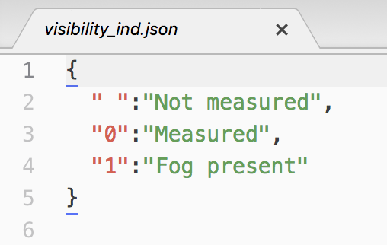

Figure 5 Example of *simple* code table

## Nested code tables

Nested code tables are included to deal with situations when a coded element’s encoding varies according to an indicator (contained in a different element in the data) or/and changes along time (different code table versions). Instead of storing these tables in separate files, it has been deemed neater to create nested code tables.

The example in Figure 6 (right) shows a code table with 2 levels of indexing. It is built as a single json object in which the *values* of the *key:value* pairs of the outer indexing level, are *simple code tables*, instead of individual values.

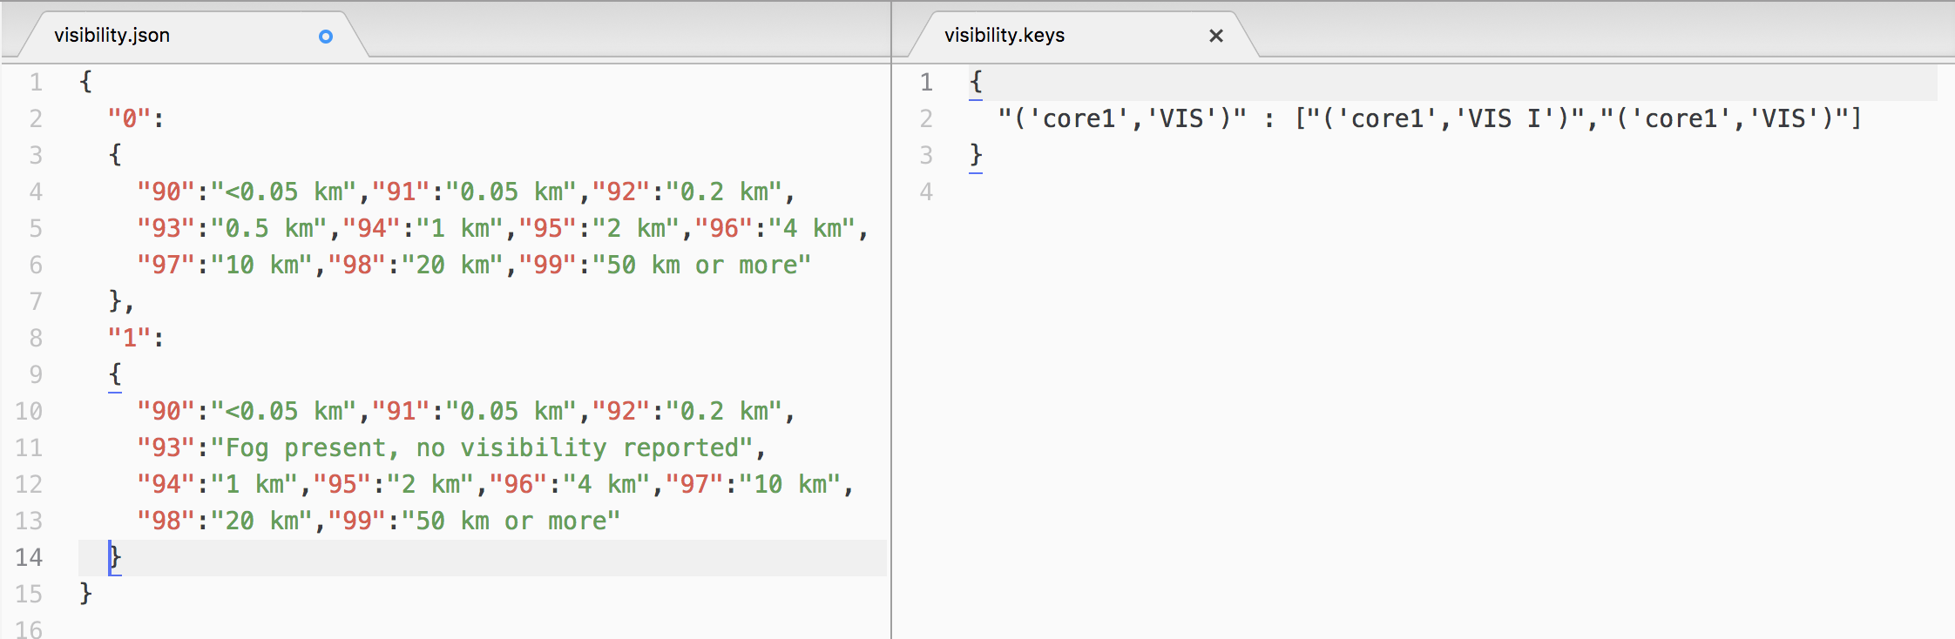

Figure 6 Example of nested table (left) and its companion keys file (right)

The data file schema provides the element:codetable correspondence. However, to map the element to its value in the code table, it is necessary to know the elements in the data file from which the outer keys are derived. Each nested table *table_name*.json has a companion json file *table_name*.keys (Figure 6, right) with a set of *key:value* pairs. The key is the actual element the table decodes and the value is a list with the complete set of key elements, from outer to inner.

As a single table can be potentially used to code different data file elements, a key must be provided for every element wishing to be decoded with that table (even if it is unique)

## Range-keyed code tables

Range-keyed code tables can be any of the simple or nested types. This term will apply if any of its key:value pairs is a range, like a period of years (1910-1945) or simply an integer interval (1-10).

Instead of building the table repeating each of the key:value pairs for the individual values in the range of the key in the json file, the range key pairs are defined as *range(init, end [, step]):value* in the json file. The code table manager will identify this special type of key and will expand the keys in the dictionary it reads internally.

Range keys rules and use:

* Only integer ranges are currently supported
* Parameter *step* is optional. Defaults to 1.
* In ranges that apply to a range of years, the keyword *yyyy* can be used in the place of the *end* parameter. It will expand the period to the current year.

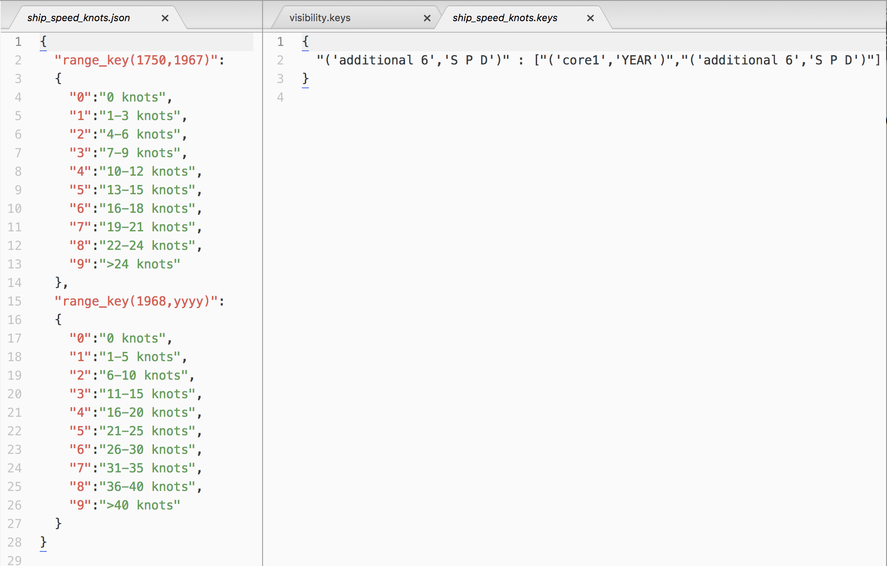

Figure 7 Example of nested range-keyed table (left) and its companion keys file (right)

## Assigning date(datetime) elements to keys

TBI. When one of the keys is a datetime (only date so far), element, depending on the data format:

* The key date element is individual: e.g. “YEAR”
* The key date element is part of a datetime element: e.g. “Odate” (%Y%m%d)

Then add ._*year* (|._*xxxx*, *xxxx*: pd.DateTimeIndex attribute https://pandas.pydata.org/pandas-docs/stable/reference/api/pandas.DatetimeIndex.html) to the element name: e.g. “Odate._year”

# Annex

## Reading supplemental data

## Time stamps management

TBD

## File format models

### Fixed width simple models

#### No sections

Alias: fixed_width_basic



#### Elements in sections

Alias: fixed_width_sections



### Fixed width complex models

#### IMMA1 model – multiple and optional sections

Alias: fixed_width_complex_opt





#### TDF-11 model – multiple and exclusive sections

Alias: fixed_width_complex_exc





#### TD14 model – multiple reports per record with common sections ( or header)

Alias: TBI



#### TD14 model – multiple reports per record

Alias: TBI



### Field delimited simple models

#### No sections

Alias: delimited_basic

See section 10.2.1.1

#### Elements in sections

Alias: delimited_sections

See section 10.2.1.2

### Field delimited complex models

Not implemented

1. Wiki: A **data model** (or **datamodel**) is an abstract model that organizes elements of [data](https://en.wikipedia.org/wiki/Data) and standardizes how they relate to one another and to properties of the real world entities
2. If NaN values are present, and *column_type* is integer, conversion to *column_type* will not be possible and data type will be as pandas casting rules (<https://pandas.pydata.org/pandas-docs/stable/user_guide/missing_data.html>: Missing data casting rules and indexing).